CLOSE ENDED 1

Q:What are the top 5 brands by receipts scanned among users 21 and over?

-- a view of users who are 21 and over

WITH user_above21 AS (

SELECT *

FROM USER_TAKEHOME

WHERE ( (strftime('%Y', 'now') - strftime('%Y', birth_date)) > 21

        AND

            (strftime('%m-%d', 'now') < strftime('%m-%d', birth_date))

          )

),

--a view of the transactions corresponding to the users 21 and over

transactions_above21 as (

SELECT *

FROM TRANSACTION_TAKEHOME

WHERE user_id IN (SELECT id FROM user_above21)

),

–count the brands based on receipts scanned

SELECT p.BRAND, COUNT(t.receipt_id) AS Total

FROM transactions_above21 t LEFT JOIN PRODUCTS_TAKEHOME p on t.BARCODE = p.BARCODE

WHERE t.BARCODE IS NOT NULL

GROUP BY p.BRAND

ORDER BY 2 DESC

LIMIT 5;

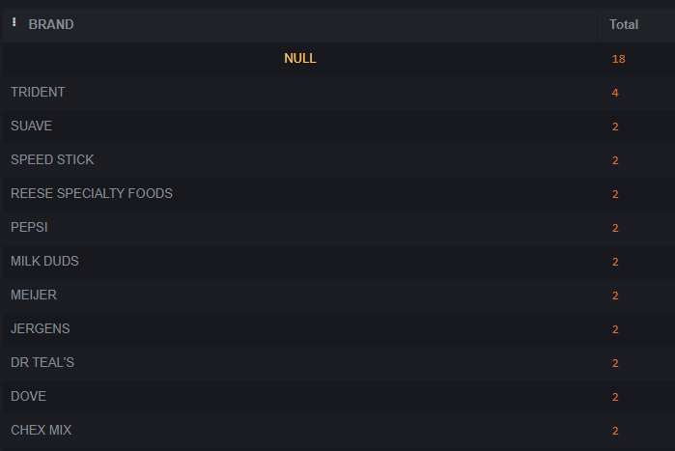– as you can see null is the highest which means that the brand name doesn’t exist, a data quality issue